|  |  |
| --- | --- |
| EGC_Black | Student Name \_\_\_\_\_\_\_\_\_\_\_\_\_\_\_\_\_\_\_\_\_\_\_    **Eastern Goldfields College**  Mathematics Essential 2019  Test 3 - Weighting 8%1 |
| **Working Time: 20 minutes** | **Marks: 19 marks** |

**Calculator Free (No notes or calculator allowed)**

**Question 1 (2 marks)**

Match each shape to its net

****

### Question 2 (4 marks – 1,3)

1. Label the different views for the following 3D shape.

|  |  |  |  |
| --- | --- | --- | --- |
| Front | View From \_\_\_\_\_\_\_\_\_\_\_\_ | View From \_\_\_\_\_\_\_\_\_\_\_\_ | View From \_\_\_\_\_\_\_\_\_\_\_\_ |

1. Draw the shape in its different views.

|  |  |  |  |
| --- | --- | --- | --- |
| Front | Plan | Front Elevation | Side Elevation |

**Question 3 (3 marks)**

On a scale of 1:30 what measurements on a plan would represent actual measurements of

1. 120cm
2. 45cm
3. 360cm

**Question 4 (4 marks)**

State two (2) properties of the following shapes

**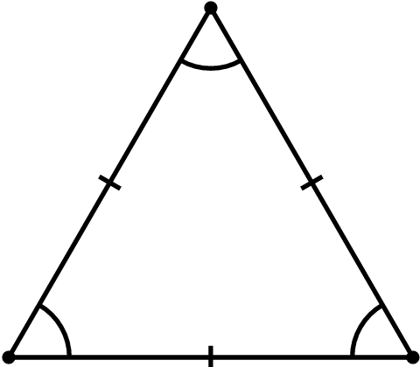**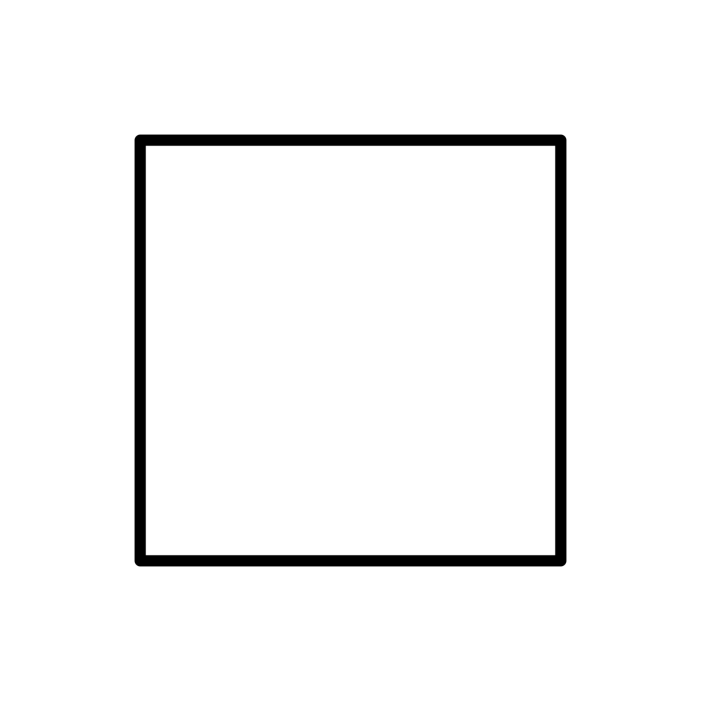

**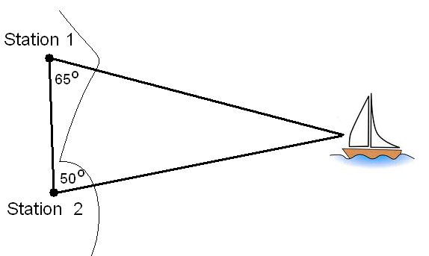Question 5 (6 marks)**

Create an accurate scale drawing of the diagram on the right to determine how far the boat is from each station.

20km

Use scale 1 = 200000

|  |  |
| --- | --- |
| EGC_Black | Student Name \_\_\_\_\_\_\_\_\_\_\_\_\_\_\_\_\_\_\_\_\_\_\_    **Eastern Goldfields College**  Mathematics Essential 2019  Test 31 |
| **Working Time: 25 minutes** | **Marks: 22 marks** |

**Calculator Assumed (Formulae sheet and one A4 page of notes)**

### Question 6 (5 marks – 2, 3)

1. Draw and name the following shape, according to the description given below:

|  |  |  |
| --- | --- | --- |
| **Description** | **Name** | **Drawing** |
| A 3D shape that is made up of:  5 faces  2 triangles and  3 rectangles. |  |  |

1. How many vertices, faces and edges does the following shape have?



**Question 7 (7 marks: 2, 2, 3)**

|  |  |
| --- | --- |
|  | Below is the floor plan for Mrs Wood’s new holiday house. |
|  | Scale 1: 200 |
|  | Using the scale given, find the area of the garage |
|  | Mrs. Wood decides that she wants to concrete the floor of the garage. If concrete costs $21.20 per square metre, how much will it cost to complete? |
|  | The bathroom, laundry and ensuite are to be tiled, with tiles costing $41.40/m2. How much will it cost to buy tiles? |

**Question 8 (4 marks – 1, 3)**

1. What is the shape of the front elevation (face A)?

**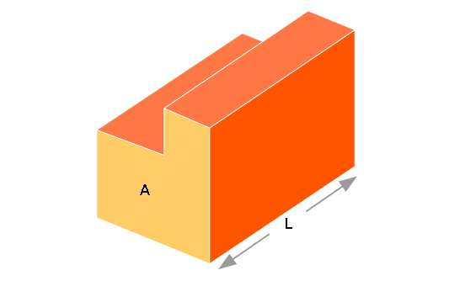**

1. Draw the net of the 3-dimensional shape

**Question 9 (3 marks)**

Bonnie is building a new kitchen cabinet to put in her house. She wants the cabinet to be 2400mm wide to fit in the alcove that already exists. To assist her, she has made a scale model that is 25mm deep, 40mm tall and 60mm wide. Assuming she keeps the same scale and fits the cabinet exactly to the width of the alcove, how tall and deep will the actual cabinet be?

**Question 10 (3 marks)**

Consider the following information:

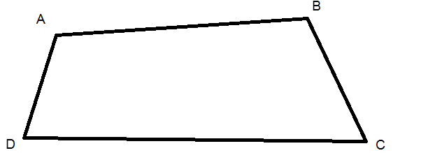

The quadrilateral shown has the following dimensions:

Side AB = 19cm

Side BC = 8.5cm

Side CD = 21cm

Side AD = 6.5cm

* A = 105°
* B = 108.5°
* C = 75°
* D = 71.5°

If the Quadrilateral ABCD was increased by a scale factor of 0.5, what would be the new measurement of:

a) Side AB

b) 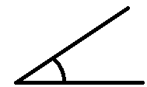B

c) Side AD

END OF TEST